
Marconi Sailing Club

Sprint 15 Traveller Event

29th & 30th April 2006

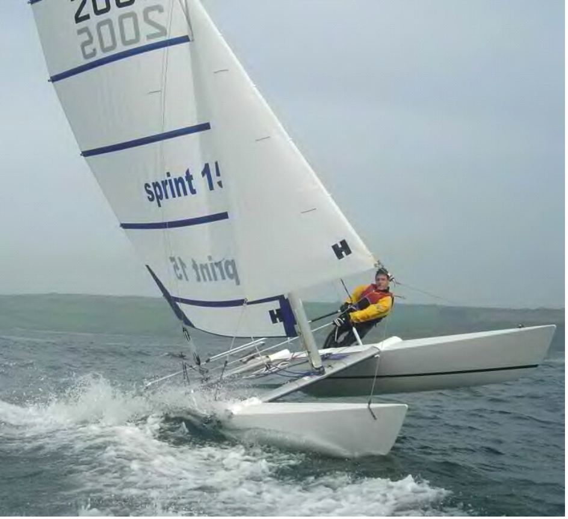

1st Briefing – 11am on Saturday 29th April
4 Races* including the Figure of Eight Northey / Osea Race*
On-site camping available on Saturday & Sunday night
Saturday Evening Meal and Entertainment

Further details available from www.sprint15.com or www.marconi-sc.org.uk
Contact: Jenny Ball – 01277 633 762 or jenny@dart15.fsnet.co.uk

Marconi Sailing Club, Stansgate Road, Steeple, Essex CM0 7NU

